Fall 2021/FSE 100

#93695

TEAM 6

**Final Report**

Basic Information

Team Number:

6

Team Members:

* Devesh Kohale
* Nianwen Dan
* Wesley Chittim
* Benjamin Steinberg

Photo of Final Design

­­­Behavior of the car

Description:

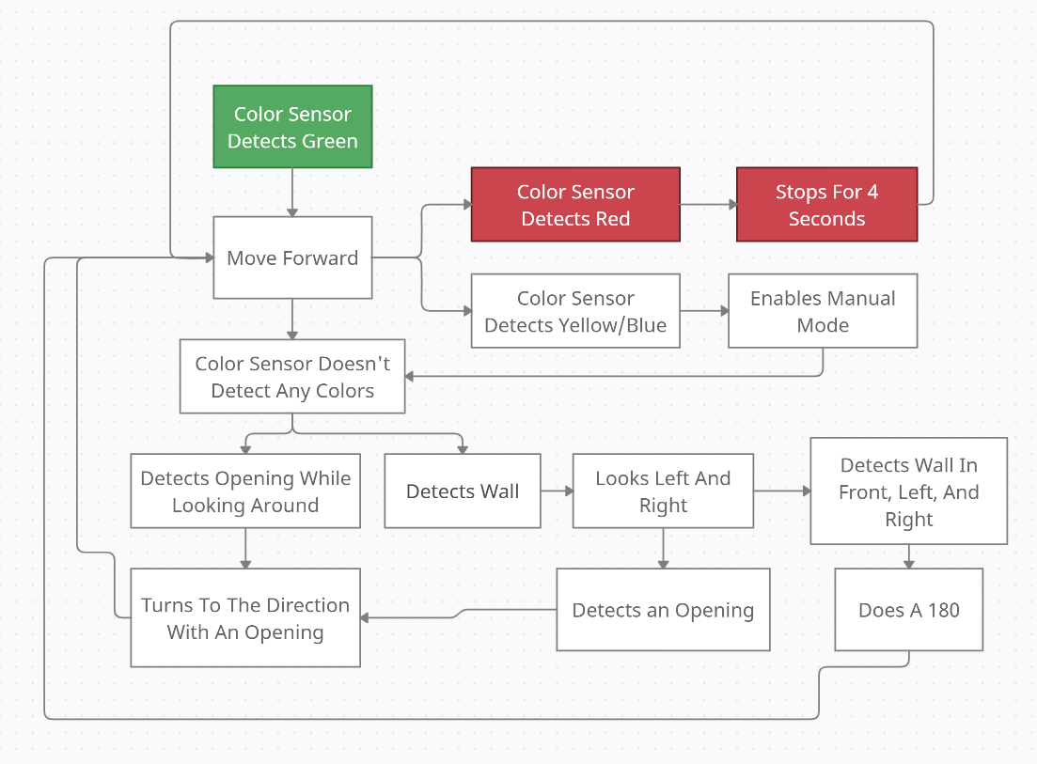

This repository is Team 6's robot for the FSE 100 project SPYN. The mission is to get the robot to pick up a disabled person in a wheelchair, maneuver through a maze we have not seen before and drop off the disabled person. For this robot, we utilize a lot of different technologies. To center the robot, we use two lesser-used technologies: Radar and Gyroscopic readings. We also utilize mathematics and radar so that the robot does not have to go anywhere it does not need to and knows there will be a dead end. Our code is commented for the most part and all in methods to keep it object-oriented and clean. This includes a Bricklink file to recreate the robot if needed and consists of all code with versions.

Table:

|  |  |  |
| --- | --- | --- |
| Description | Status | Comment |
| Integrate the Sensor into the Car | Normal |  |
| Create Code for Red | Normal |  |
| Create Code for Green | Normal |  |
| Create Code for Yellow | Normal |  |
| Create Code for Blue | Normal |  |
| Complete Code for the Color Sensor | Normal |  |
| Get the Car to Detect Walls | Normal |  |
| Get the Car to Move Left on its Own | Normal |  |
| Get the Car to do a 180 After A Left Turn | Normal |  |
| Make the Car React to Walls | Normal |  |
| Have the Car Navigate a Maze | Normal |  |
| Have the Car Move Based on Color | Normal |  |
| Construct the Lift Mechanism | Normal |  |
| Connect the Lift Mechanism | Normal |  |
| Create the Code for the Lift Mechanism | Normal |  |
| Execute Code on the Car | Normal |  |
| Control the Lift Mechanism from the Keyboard | Normal |  |

YouTube Video

Link to Watch:

](https://youtu.be/B7rBDubfS4k)

[Use this link if the picture one is not working.](https://youtu.be/B7rBDubfS4k)

Source Code

File Download:

[Click Here To Download](https://1drv.ms/u/s!AoR-o4C9NbbA0xv-oLuXxFcFF8T0?e=H3lOKo)

File Breakdown:

* main() this is the main method
* readforward() takes the distance ahead of it
* readleft() takes the distance to the left of it
* readright() takes the distance to the right of it
* left() turns left
* right() turns right
* stop() stops the drive motors
* straight() moves the drive motors straight
* radar() this moves the sensor and takes data points
* centering() centers the robot utilizing the radar functionality
* gyro() centers the robot by utilizing the gyro
* remote() remote for moving forward, backward, right, left
* colorread() reads the color pads to enable remote(), start and stop
* turnlogic() does the logic on wether or not to turn
* deadend() what happends if the robot reaches a dead end